**Introduction**

Recently, as a result of the FFR hikes, it has caused great turbulence in the global financial markets. This not only brough about a short-term strength in the US dollar, which significantly influenced the FX market, but also affected the pricing of the rest of the assets as well as the anchoring of sovereign credits. Many investors focused on the volatility of the FFR, the tone given by the Feds, and the official dot plots, in an attempt to make better predictions about the FFR to protect their portfolios or even make profits. Notably, Taylor Rule is a popular approach for Fed to build the relationship between the FFR and the macro conditions, which are explained mainly by Resource Gap measured by GDP and Inflation measured by PCE. Based on the Taylor Rule, the investors and institutions can make projections for the FFR with the publicly available information.

According to the basic assumptions of time series modelling, forecasts at moment t cannot use future information, but only current moment as well as ever information [17]. However, in the actual publication of economics data, although different economic indicators reflect economic conditions over the same period of time, they cannot be regarded as variables with the same time stamp due to the difference in publication time. This is also the case in this study, although based on the Taylor Rule, the FFR can be calculated using the relevant macroeconomic indicators for this period, the corresponding macroeconomic indicators are published 1-2 days after the publication time of the FFR, and therefore it is impossible to use such future information for FFR determination in practice. As being visualized through Fig.1, the FFR is released at the end of the quarter, but the corresponding macro data is released afterwards. In reality, researchers generally use the previous period's macroeconomic data as the input factor for the Taylor Rule, however, this can lead to a lagged effect as the calculation of the FFR ignores the most recent period's economic situation. There are also many relevant financial institutions that present alternative data for use, but this is not always publicly available and authoritative.

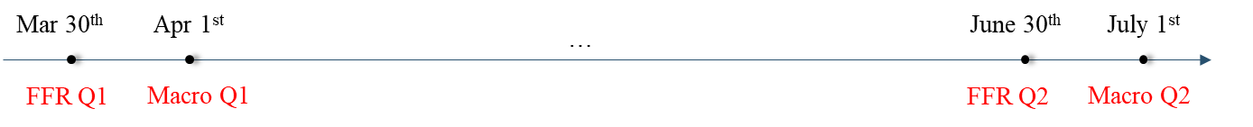

Figure 1. The release example of FFR and Macro Data

Moreover, especially the U.S. Gross Domestic Product (GDP) lags much more compared to the inflation data, as it has multiple revisions to provide more reliable predictions. It is because the GDP revisions involve updating and refining previously released GDP data to provide a more accurate and comprehensive representation of economic activity. Revisions are a normal part of the economic data reporting process, as initial estimates are often based on incomplete information and preliminary data. The diagram presented below illustrates the release and adjustment of GDP throughout the year 2023. To illustrate, the initial GDP release on January 26th, 2023, is essentially a forecast, and it undergoes its first revision on February 23rd, 2023, which, nonetheless, remains a prediction. It is only by March 30th, 2023, that the released GDP becomes a more comparatively accurate figure. A comprehensive explanation of the modification process is put in Appendix 1.

Figure 2. Release and Modification of GDP in 2023

Although Taylor Rule has the obstacles, it also proves the effectiveness of the Resource Gap and Inflation towards the FFR prediction, and the indicated the linear relationship, which can be further studied by applying the rolling linear regression to make more accurate estimation as the coefficient are ever-changing instead of setting preliminarily. In this study, we aim to embed the information from daily Treasury Yield data, which is achieved by applying the Hidden Markov Model with Gaussian Mixture Models (GMM-HMM), to make timelier information projection. And by combing this obtained information and the original Macro data, a rolling regression model is fitted with the historical data, and hence makes a one step ahead prediction for the FFR rates. All the experiments are completed with Python, which is fully accessible on [*Github*](https://github.com/FanZixian/HKU_ECON4200_GP).

**Literature Review**

1. Federal Reserve Rate
   1. Monetary Policy

The Federal Reserve, through its monetary policy adjustments, creates a favorable economic environment characterized by appropriate employment rate and stable price [1]. When the aggregate demand lags the economy's capacity to produce, it results in increased unemployment rate and reduced inflation. To counter this, the Federal Open Market Committee (FOMC) intervenes by reducing interest rates and implementing an expansionary monetary policy to stimulate aggregate demand, thereby helping stabilize the economy.

Conversely, if demand for goods and services becomes excessively strong, it can lead to unsustainably employment rate and increased inflation, leading the Federal Reserve employs a contractionary monetary policy by elevating interest rates to guide economic activity back to normal level. The procedure through which the FOMC enacts expansionary and contractionary monetary policies to achieve its goals can be summarized as shown in Fig.3 [2].

Figure 3. Federal Reserve Monetary Policy

* 1. FFR

The primary method to exert monetary policy is the adjustment of the federal funds rate (FFR) [3]. Banks maintain reserve balances at the Federal Reserve to fulfill unforeseen liquidity requirements, so they engage in borrowing and lending of reserves among one another based on their specific needs. The federal funds rate represents the interest rate at which banks engage in overnight borrowing, which plays a pivotal role in determining the expense of short-term credit.

To impact the federal funds rate, the FOMC can modify the interest rate applied to bank reserves. This adjustment leads to changes in the federal funds rate, aligning it with the FOMC's desired objectives and influencing the cost of short-term interbank credit.

In response to the 2008 economic crisis and subsequent economic recession, Federal Open Market Committee lower the target for the federal funds rate from 5.25% in mid-September 2007 to near zero by the end of December 2008 (See Fig. 4) [4]. This rate reduction was part of the Fed's strategy to stimulate economic activity and provide liquidity to the financial system. The goal was to make borrowing cheaper for banks, businesses, and consumers to encourage spending, investment, and lending. Together with various monetary policies such as buying back government securities, the market responded by purchasing large-scale assets, consequently fostering economic growth, job generation, and a gradual resurgence of inflation toward 2% [2]. Notably, in December 2015, the Federal Open Market Committee initiated the process of increasing the target for the federal funds rate, transitioning from its near-zero level to a more conventional rate. Subsequently, in October 2017, the Federal Open Market Committee embarked on the gradual reduction of its securities holdings, marking another substantial step toward the normalization of monetary policy [5]. As part of this shift, the Committee conveyed that future adjustments in the federal funds rate would serve as the primary mechanism for altering the overall stance of monetary policy.

In the recent context, the U.S. economy has been experiencing a robust recovery after a period of economic disruption, possibly due to the COVID-19 pandemic. Annual inflation rates have risen above the Federal Reserve's target of 2%. Inflation, as measured by the Consumer Price Index (CPI), is at 3.5%, and core inflation (excluding food and energy) is at 2.8%. To address these economic conditions, the Federal Reserve announces an increase in the target FFR from 0.25% to 0.50% [5]. This is the first-rate hike in several years, signaling the central bank's confidence in the strength of the economic recovery.

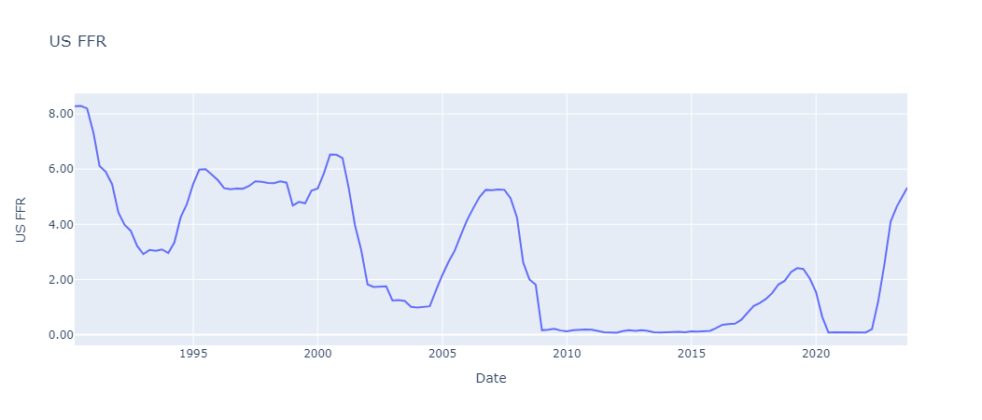

Figure 4. US Effective FFR Diagram

1. Taylor Rule

In a paper published in 1993, John Taylor showed how monetary policy in the United States from 1987 to 1992 was approximated by a formula that related the federal funds rate to three variables. The first variable is the inflation-adjusted long-run federal funds rate, the second is the deviation of current inflation from the 2% target set by the Federal Open Market Committee (FOMC), and the third is the percentage difference between actual GDP and its potential level.

Taylor Rule takes the following general form, with the specific meanings of the indicators shown in the table below [6].

$$R_{t}^{T}=r_{t}^{LR}+π_{t}+0.5\left(π_{t}-π^{*}\right)+0.5(y_{t}-y^{*})$$

|  |  |
| --- | --- |
| Variable | Implication |
| $${FFR}_{t}$$ | Federal fund Rate |
| $${rLR}_{t}$$ | Real Neutral Rate |
| $$π_{t}$$ | Expected Inflation |
| 𝜋∗ | Target Inflation |
| $y_{t}$ − ${yp}_{t}$ | Percent deviation between the current real GDP and the long-term linear trend in GDP |

Table 1. Variables Explanation in Taylor Rule

The Taylor formula illustrates that when inflation surpasses the 2% target, the federal funds rate increases at a rate 1.5 times that of the inflation increase. Furthermore, if the GDP exceeds its potential level, the federal funds rate increases by 0.5 times the difference between the GDP and its potential level.

The Taylor rule embodies the fundamental principles of monetary policy discussed earlier. Firstly, when the real long-term neutral federal funds rate, the actual and target inflation rates, and the real GDP level and its potential are all known, the adjustment based on the difference between the GDP and its potential level is zero, making FFR prediction feasible. Secondly, it advocates for higher FFR in response to rising inflation or increased resource utilization, and lower FFR when inflation subsides or resource utilization declines. This alignment corresponds with the Federal Reserve's dual mandate. Lastly, the equation dictates that the federal funds rate should be adjusted by more than a one-to-one ratio when inflation experiences upward or downward movements, a characteristic often referred to as the Taylor principle.

Federal Reserve officials and economists later introduced several alterations to the variables used in the Taylor Rule, aiming to provide a more accurate representation and interpretation of shifts in the real-world scenario and policy structure. As a result, numerous revised iterations emerged (Table. 2) [7].

|  |  |  |  |
| --- | --- | --- | --- |
| Rules | Formula | Coefficient of Resource Gap | Coefficient of Inflation |
| Bernanke Rule | $$FFR_{t}=r_{t}^{LR}+π_{t}+0.5\left(π_{t}-π^{⋆}\right)+(y_{t}-y^{⋆})$$ | 1 | 0.5 |
| Evans Rule | $$FFR_{t}=r_{t}^{LR}+π_{t+1}+0.5\left(π_{t}-π^{⋆}\right)+2(u_{t}-u^{⋆})$$ | 2 | 0.5 |
| Yellen Rule | $$FFR_{t}=r_{t}^{LR}+π_{t+1}+0.5\left(π_{t}-π^{⋆}\right)+2(u_{t}-u^{⋆})$$ | 0.5 | 2 |
| Bullard Rule | $$FFR_{t}=ρ{FFR_{t-1}+\left(1-ρ\right)[r}_{t}^{LR}+π^{⋆}+β_{1}\left(π_{t}-π^{⋆}\right)+β_{2}(u_{t}-u^{⋆})]$$ | 0.1 | 1.5 |

Table 2. Adjusted versions of Taylor Rule

1. Treasury Yield

U.S. Treasury yield is the yield on U.S. government bonds, whose metric measures the return an investor can earn by purchasing U.S. government bonds. U.S. government bonds are bonds issued by the government to raise funds and are usually classified as having different maturities, including short-term, intermediate-term, and long-term bonds.

Treasury yield is often used by investors and economic observers as an indicator of risk and market expectations. Based on the risk-neutral interpretation, treasury yields are equal to the average value of expected future short rates [8]. A low Treasury yield may indicate market concerns about future economic uncertainty, while a high Treasury yield may reflect investor optimism about economic growth and inflation. In addition, Treasury yield is used to determine the pricing of other financial instruments, such as mortgage rates and corporate bonds. Treasury yields can reflect economic conditions, monetary and fiscal policies, and expectations about future economic activity, real interest rates, and inflation [9]. What can be agreed upon is that whenever macroeconomic data is released differently than the consensus, treasury yields always have a noticeable jump, indicating the influence of macro economy situations to the treasury yields. In this research, we take 6 U.S. treasury yields from Bloomberg into consideration according to the dataset coverage [10], and the remained NAN values are forward filled based on the previous dates’ yield data. A visualization of the Treasury Yields is shown in Fig. 5:

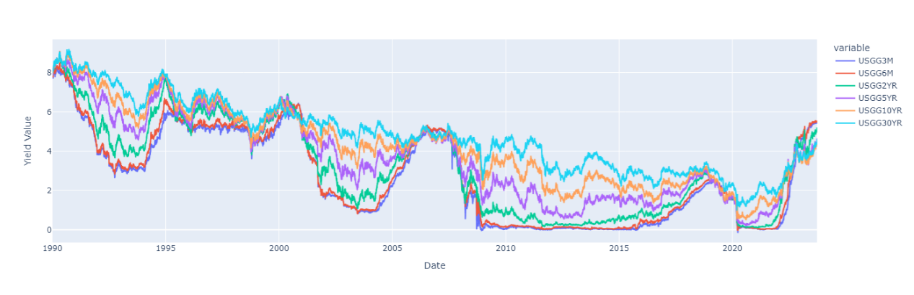

Figure 5. US Treasury Yields Diagram (Maturities including 3, 6 Months, 2, 5, 10, and 30 Year)

Additionally, the term structure of the treasury yields is also an important dimension to understand the economic situation at that point of time. First, regarding the shape of the yield curve at a given point in time, broadly speaking the curve should show an upward sloping trend, but the rate of increase in interest rates decays as maturity increases. This shape is supported by the principles of Expectation, Bond Risk Premiums, and Convexity Bias as stated by Ilmanen. [11] In the history, researchers were interested in proposing models to fit the treasury yield curve better or analyzing the components from the yield curve, and there are indeed the components named level, slope, and curvature that is economically explainable to the structure of yield curve [12]. By reviewing the yield curve in Fig. 3, we can visualize that the up and down shifts in the interest rate curve are essentially joint (as measured by level), and that in most cases the curve with high maturity lies on top (can be illustrated by slope). Various experimented models can prove the existence and significance of these three components, such as the Nelson-Siegel Model [13, 14]. However, this model required some essential tricks to determine the parameters in the model so as to provide a better simulation result. There is another easier method, which is named the Principal Component Analysis that is frequently used in Statistics and Data Science to reduce the dimensionally of the features and get the important ones, that is proved to be useful to model these three factors [15]. From this method, the first three important factors are representing the level, slope, and curvature components in the yield curve, while the remaining are assumed to be noise and filtered out.

Indeed, treasury yields have strong correlation with FFR, especially in the short-term tenor parts, which is because the short-term rate is linked to the FFR to some extent. [16] However, the raise of FFR doesn’t necessarily provide evidence for the change of long-term yield. It can be concluded that this kind of situation could flatten the yield curve as the short side increases more than the long side. We perform a simple correlation measurement to the FFR and the monthly treasury yield rate in Fig. 6, and it is found that the correlation is very close to 1. Whereas, if we lag the treasury yield rate 1 year before and still apply the correlation test, the relationship is still relatively stable. It seems that the treasury yield cannot be directly used as an instrument to project the FFR in the future.

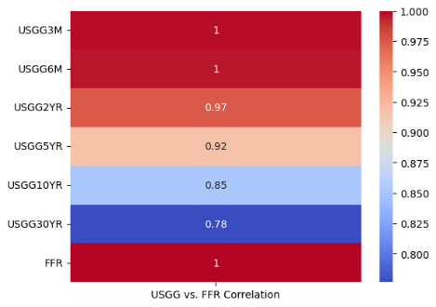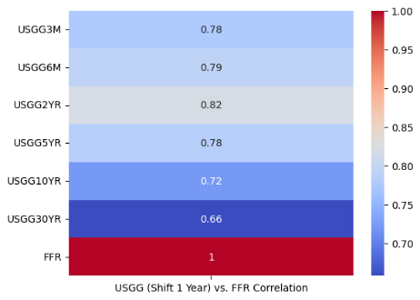

Figure 6. Correlation between the FFR and monthly Treasury yield (Left) v.s. Correlation between the FFR and monthly Treasury yield on year before (Right)

**Research Objective**

1. Transform the treasury yields data into explanatory features, and then feed them to the GMM-HMM to obtain the leading macroeconomics factors.
2. Construct the model based on the traditional Taylor Rule and generated new macro factors, that is a linear model:
$${FFR}_{t}=β_{1,t}{Resource Gap}_{t-1}+β_{2,t}{PCE}_{t-1}+β_{k, t}Variable_{k}+ϵ_{t}$$

3. Adjust the incorporated information window to test the projection performance of the model.

**Dataset Description**

Both the Treasury yield data and FFR are downloaded from HKU Bloomberg Laboratory [10]. Note that the FFR is actually called effective FFR, which is further explained in Appendix 2. The Macro data of Real GDP, Potential GDP, and PCE are downloaded from FRED Economic Data website [18]. The Resource GAP is measured by the logarithmic transformation of Real GDP minus the logarithmic transformation of Potential GDP. All the data are set to start from 1990-01-01.

**Methodologies**

1. Principal Component Analysis (PCA)

The goal of the PCA method is to reduce the dimensionality of the data without losing much meaningful information, which can even filter out the noise. In this study, the PCA is utilized to reduce the components of yield curve from 6 original curves to 3 meaningful components that can be classified to Level, Slope, and Curvature. The detailed steps are shown below:

1. Get the covariance matrix of all yields data $C$.
2. Calculate the eigenvalues and eigenvectors of $C$.
3. Select some best eigenvalues, and project the original data to the corresponding eigenvectors. The eigenvectors represent the new dimensions that the original features are projected to, which are called the principal components. And the eigenvalues are the mode of the new projected vectors on the principal components.

From these three steps, we can obtain the 3 components on a daily basis, and they can also be combined to rebuild the yield curve. An example of the PCA method utilized for 1991 Q1 is shown in Fig. 7. The left diagram shows the cases of Level, Slope, and Curvature, which can be easily understood. The Level value for yield with different maturities are all greater than 0, meaning that the curve can move upwards or downwards simultaneously according to the change of Level.

Figure 7. The values that the original 6 yield curves projected on the principal components (Left); The daily Level, Slope, and Curvature values provided by PCA during 1991 Q1 (Middle); Rebuilt Yield Values compared to Original Yield Values of USGG6M (Right)

1. Hidden Markov Model with Gaussian Mixture Models (GMM-HMM)

Under the assumption, macroeconomic conditions are affected by the newly released FFR, after which it continues to operate on its own. The yield curve is to some extent a reaction to the macro data, and when there are optimistic expectations about the economic trend, the yield curve will go down. The state of the macroeconomic situation is positional during this period of time, but we can observe changes in the Treasury. And the change in Treasury yield is not only affected by GDP and Inflation, but it may also be affected by other macro data releases (e.g., non-farm payroll), Fed speeches, changes in the political situation, and all of these are likewise outward forms of the macroeconomic situation. Therefore, this study aims to use the GMM-HMM to create new variables from the Treasury yield data that can describe the macroeconomic situation from another aspect.

For the HMM, we had the notations:

Set of hidden states: $H=\left\{h_{1},h_{2},…,h_{N}\right\}$

Set of observable states: $O=\left\{o_{1},o_{2},…, o_{M}\right\}$

The series of hidden states: $I=\left\{i_{1},i_{2},…, i_{T}\right\}, i_{t}∈H$

The series of observable states: $J=\left\{j_{1},j_{2},…, j_{T}\right\}, j_{t}∈O$

Parameters: $λ=\left(A,B,II\right)$

Hidden States Transition Probability (how the hidden states from $t-1$ change to $t$):

$$A={\left(a_{ij}\right)}_{N×N}$$

How the hidden states can come up with the observable states:

$$B={\left[b_{j}\left(k\right)\right]}_{N×M}$$

The initial states at $t=0$, which is the probability $q_{i}$

$$II={\left[π\left(i\right)\right]}_{N}, π\left(i\right)=p\left(i_{1}\right)=q_{i}$$

It is assumed that the series of hidden states follows Markov Assumption, that the current state at $t$ is only dependent on the state at $t-1$ and the constant hidden states transition probability matrix $A$, but not any of the prior state data. And the observable states at $t$ is only determined by the hidden states at time $t$ and the matrix $B$.

The above statements are for the general discrete HMM model, but in this study, the states are not discrete, but instead continuous. Hence, the discrete probability measurement cannot be directly used in this situation, and Gaussian Mixture Model can be applied instead. Gaussian Mixture Model is a probabilistic model used for representing a mixture of multiple Gaussian distributions, which is an extension of the traditional Gaussian Model. It is a generative model that assumes all the data points follow a mixture of several Gaussian distributions with unknown parameters. It can be formulated step-by-step, and the final Gaussian Mixture Model is applied to substitute the probabilities in the discrete HMM model:

P.D.F. of Univariate Gaussian Model:

$$f\left(x | μ, σ^{2}\right)=\frac{1}{\sqrt{2πσ^{2}}}exp⁡(-\frac{{\left(x-μ\right)}^{2}}{2σ^{2}})$$

P.D.F. of Multivariate Gaussian Distribution:

$$f\left(X | μ, Σ\right)=\frac{1}{{\left(2π\right)}^{\frac{D}{2}}{\left|Σ\right|}^{\frac{1}{2}} }exp⁡(-\frac{1}{2}{\left(X-μ\right)}^{T}Σ^{-1}\left(X-μ\right))$$

P.D.F. of Gaussian Mixture Model:

$$f\left(X\right)=\sum_{k=1}^{K}{π_{k} ⋅f_{k}\left(X | μ_{k}, Σ_{k}\right)}$$

where:

$π_{k}$ is the weight of the k-th component, with $\sum_{k=1}^{K}{π_{k} }=1$

$f_{k}\left(X | μ_{k}, Σ_{k}\right)$ is the P.D.F. of the k-th Multivariate Gaussian Distribution

The target of this study is to obtain the last projection of the hidden states, which is $h_{t}$, and then utilized as the variable for rolling regression fitting. To obtain the estimation of this value, the Viterbi Algorithm is utilized, which is detailed in Appendix 3.

1. Rolling Regression

Rolling Regression approach is a statistical technique used in time-series analysis, which involves estimating regression relationships over sequential subsamples, where the subsamples move forward through time. This allows for the examination of how the regression coefficients change over time as new observations are included, and it will make use of all the available information but not the future information, which aligns with the research requirements.

In the study, after the new macro variables generated from GMM-HMM, they are incorporated into the rolling regression model with the original Macro data together, and fit the multivariate linear regression model each quarter. The projection of the FFR is made one quarter ahead of the fitted model, and all the projections are joint to form the predicted FFR series. The formulas are:

$$Y_{t}=β_{t}X_{t}+ϵ_{t}$$

$$X_{t}=X_{t-1} append x_{t}$$

The min_data_points is set to be 12, indicating the data points number to fit the regression model is at least 12.

**Results Analysis**

It is essential to confirm all the data matching in this study, as the aim is to provide a practical forecasting model that can be directly used in real situations. After obtaining the dataset, this study rearranged the time index of FFR to be the start of next month, which represents the FFR of the end of last quarter, as required by Python that the index of explanatory variables and response variables are required to be matched. For instance:

* Macro_df data (Macro information dataset contains both the original macro variables and the generated macro variables): 2023-04-01 represents the Macro data for Quarter 2.
* FFR_df data (FFR Dataset): 2023-10-01 represents the FFR for Quarter 3.
* Actual FFR release: Q2 on 2023-06-30, Q3 on 2023-09-30.

Hence the model only includes Macro_df data of 2023-04-01 and the information of treasury yields from 2023-06-30 to 2023-09-29 to do the modeling.

1. Traditional Taylor Rule

By applying the Taylor Rule formula to the obtained dataset as described before, FFR can be predicted sequentially and hence compared to the real FFR. In order to evaluate the prediction performance, the Mean Square Error (MSE) metric is used, with the formula $MSE=\frac{1}{n}\sum_{i=1}^{n}{{\left(y_{i}-\hat{y_{i}}\right)}^{2}}$. From Fig. 8, it can be clearly observed that the projection has captured the trend of the real FFR, but the value is not accurate, and even always overestimates the real FFR. By the MSE measurement, the calculated MSE of the Traditional Taylor Rule is 10.13, which is our benchmark to break.

Figure 8. Plot of Real FFR and Projected FFR based on Taylor Rule

1. Rolling Regression Taylor Rule

Here the rolling regression model with the two variables, Resource Gap and PCE, is fitted to predict the Federal Funds rate sequentially, which is shown in Fig. 9. It can be seen that the prediction is much closer to the real FFR than Traditional Taylor Rule, as the model is fitted in a rolling basis that considers all the information prior to the prediction. The MSE is 1.0258, which is much lower than the Traditional Taylor Rule prediction.

Figure 9. Plot of Real FFR and Projected FFR based on Rolling Regression Model

1. Rolling Regression with variables from GMM-HMM

After

**Recommendations**

Since the release of macro data has the characteristic of lag, however, the integration of Hidden Markov Model (GMM-HMM), is able to use daily released data, treasury yield, to project the Federal Fund Rate (FFR), offering a series of benefits for the general public, policymakers, statistics agencies, financial institutions, and individual investors.

The main recommendation for policymakers comes from the model's capacity to process daily treasury yield data releases, providing a precise and real-time indicator of market sentiment. Unlike the usual reliance on quarterly macro statistics, this method gives policymakers the ability to make timely and well-informed decisions. The additional layer of information provided by the GMM-HMM model's capacity to detect latent states within the Treasury yield data enables policymakers to identify specific market situations that could impact the FFR. It is therefore advised that policymakers consider the incorporation of using the HMM model, making use of its real-time capabilities and sophisticated comprehension of market dynamics to create monetary policies that are more flexible and successful.

Integrating the GMM-HMM model into forecasting frameworks can greatly help statistical agencies. The model's ability to handle high-frequency Treasury yield data mitigates the lag present in conventional macroeconomic indicators, which is the basis for this proposal. Statistics agencies can generate more accurate and useful datasets for economic research, analysis, and forecasting. The capacity of the GMM-HMM model to present a more complex picture of the economic environment allows statistics agencies to produce insights that are timelier and accurately represent the underlying market dynamics.

The research offers a significant alternative for general investors who are attempting to understand the complexities of financial markets. As a result, investors have greater access to information sources and have a deeper comprehension of both upcoming interest rate adjustments and broader economic trends. The adaptable nature of the financial markets is caught by the dynamic and responsive aspects of the model, which enable investors to make well-informed decisions in response to shifting economic conditions.

To sum up, our research of using HMM model to project FFR presents policymakers, statistical agencies, and general investors with a novel approach. It is advised that policymakers use the model's real-time capabilities to make more intelligent and nimble financial judgments. Statistical agencies are recommended to use this modeling method to generate faster and more accurate datasets, which will improve economic assessments. Finally, ordinary investors who accept the FFR estimates offered by the GMM-HMM model can utilize its dynamic and responsive character to negotiate the intricacies of financial markets more adeptly and nimbly.

**Conclusion**

**Appendix**

1. **The U.S. GDP Revision Details**

GDP revision is to improve the accuracy and precision of GDP estimates. The process, which was started with the quarterly release of preliminary GDP figures, is based on a variety of data sources, such as economic indicators and surveys. But given the lack of some lagging indicators, these preliminary estimates might be inaccurate. Data collection continues after the first publication and includes revised business surveys, tax returns, and more economic data. The updated GDP estimates are then made available on a regular basis in subsequent phases, such as preliminary and final estimates for particular quarters or years. Furthermore, to reassess GDP data for a number of years, periodic historical revisions are carried out to consider modifications to methodologies or the addition of new data sources. Through a thorough and iterative process, GDP estimates are guaranteed to be in line with the most recent and accurate data available, giving the public, businesses, and policymakers a more sophisticated understanding of economic performance over time [].

1. **Definition of Effective Federal Funds Rate**

The federal funds market consists of domestic unsecured borrowings in U.S. dollars by depository institutions from other depository institutions and certain other entities, primarily government-sponsored enterprises. The effective federal funds rate (EFFR) is calculated as a volume-weighted median of overnight federal funds transactions reported in the FR 2420 Report of Selected Money Market Rates [].

1. **Viterbi Algorithm Details for solving GMM-HMM**